LINUX BASIC COMMANDS FOR NETWORKS
Ifconfig:
ifconfig utility is used to configure network interface parameters.
Mostly we use this command to check the IP address assigned to the system.
ifconfig –a
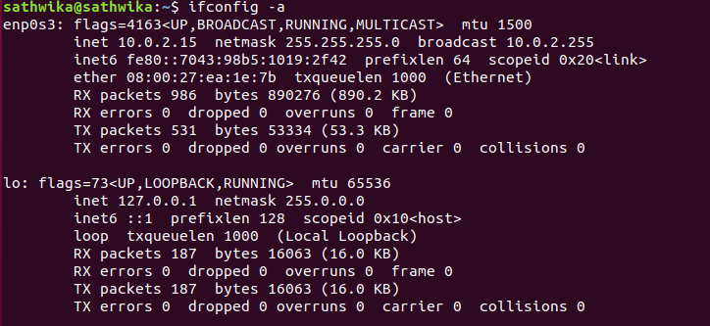

traceroute:
traceroute print the route packets take to network host.
Destination host or IP is mandatory parameter to use this utility.
traceroute google.com
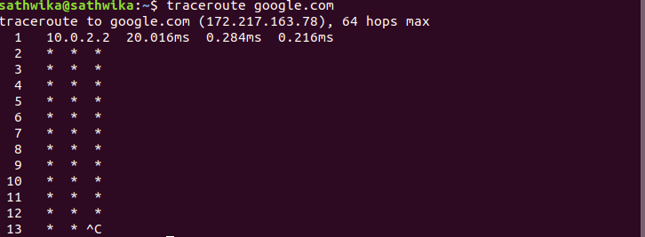
dig:
dig (Domain Information Groper) is a flexible tool for interrogating DNS name servers.
It performs DNS lookups and displays the answers that are returned from the name servers.
dig google.com
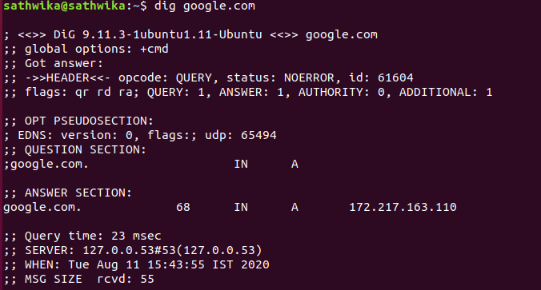

telnet:
telnet connect destination host:port via a telnet protocol if connection establishes means connectivity between two hosts is working fine.
telnet google.com 443
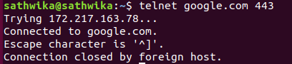

nslookup:
nslookup is a program to query Internet domain name servers.
nslookup google.com
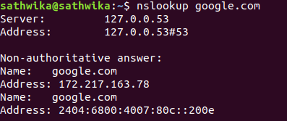
netstat:
netstat command allows you a simple way to review each of your network connections and open sockets.
netstat with head output is very helpful while performing web server troubleshooting.
Netstat
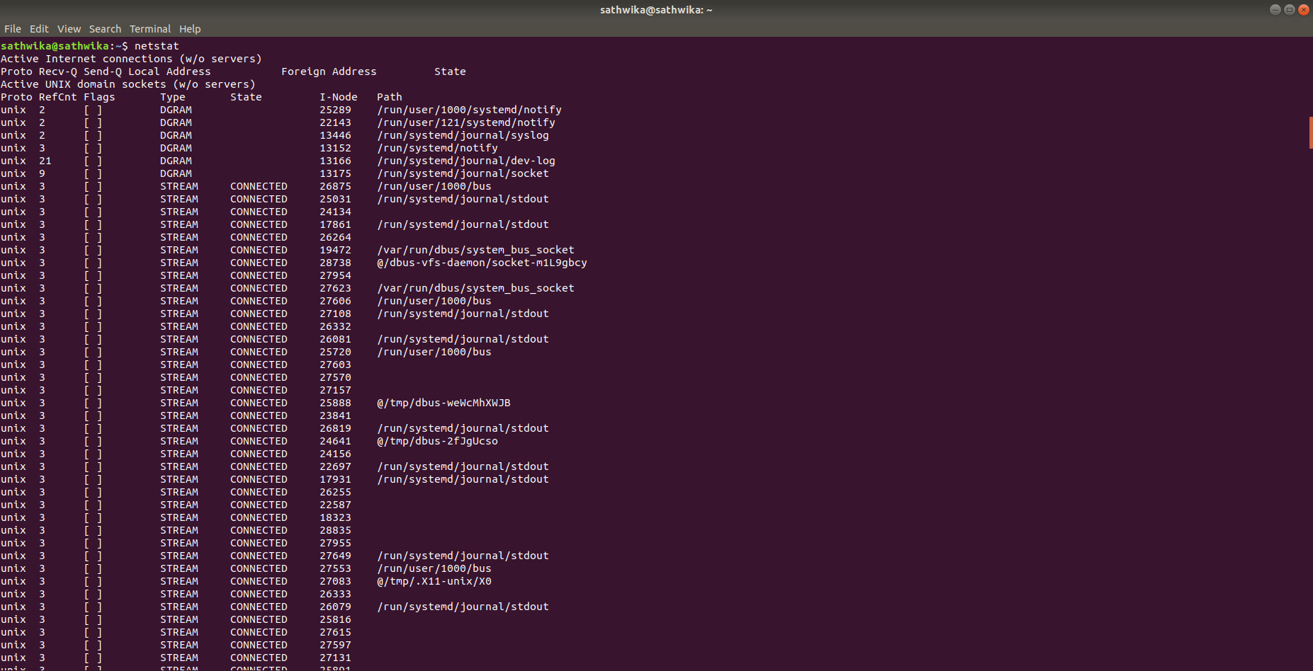
ARP Command
ARP (Address Resolution Protocol) is useful to view / add the contents of the kernel’s ARP tables. To see default table use the command as.
w:
w prints a summary of the current activity on the system, including what each user is doing, and their processes.
Also list the logged in users and system load average for the past 1, 5, and 15 minutes.
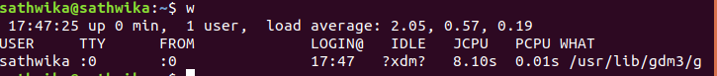
PING :
PING (Packet Internet Groper) command is the best way to test connectivity between two nodes. Whether it is Local Area Network (LAN) or Wide Area Network (WAN). Ping use ICMP (Internet Control Message Protocol) to communicate to other devices. You can ping host name of ip address using below command.
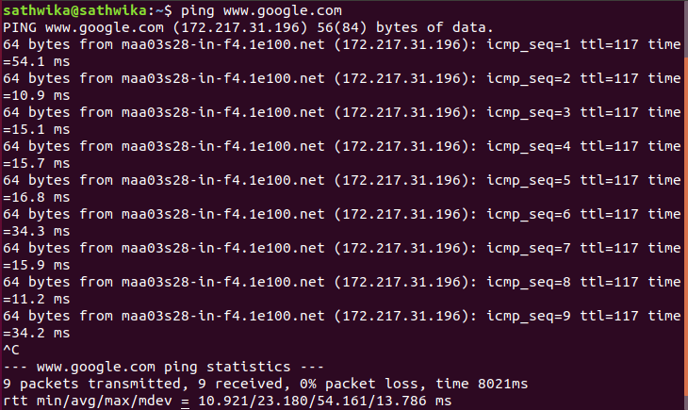

HOST Command:
host command to find name to IP or IP to name in IPv4 or IPv6 and also query DNS records.
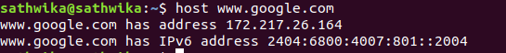
windows commands:
ipconfig-all:
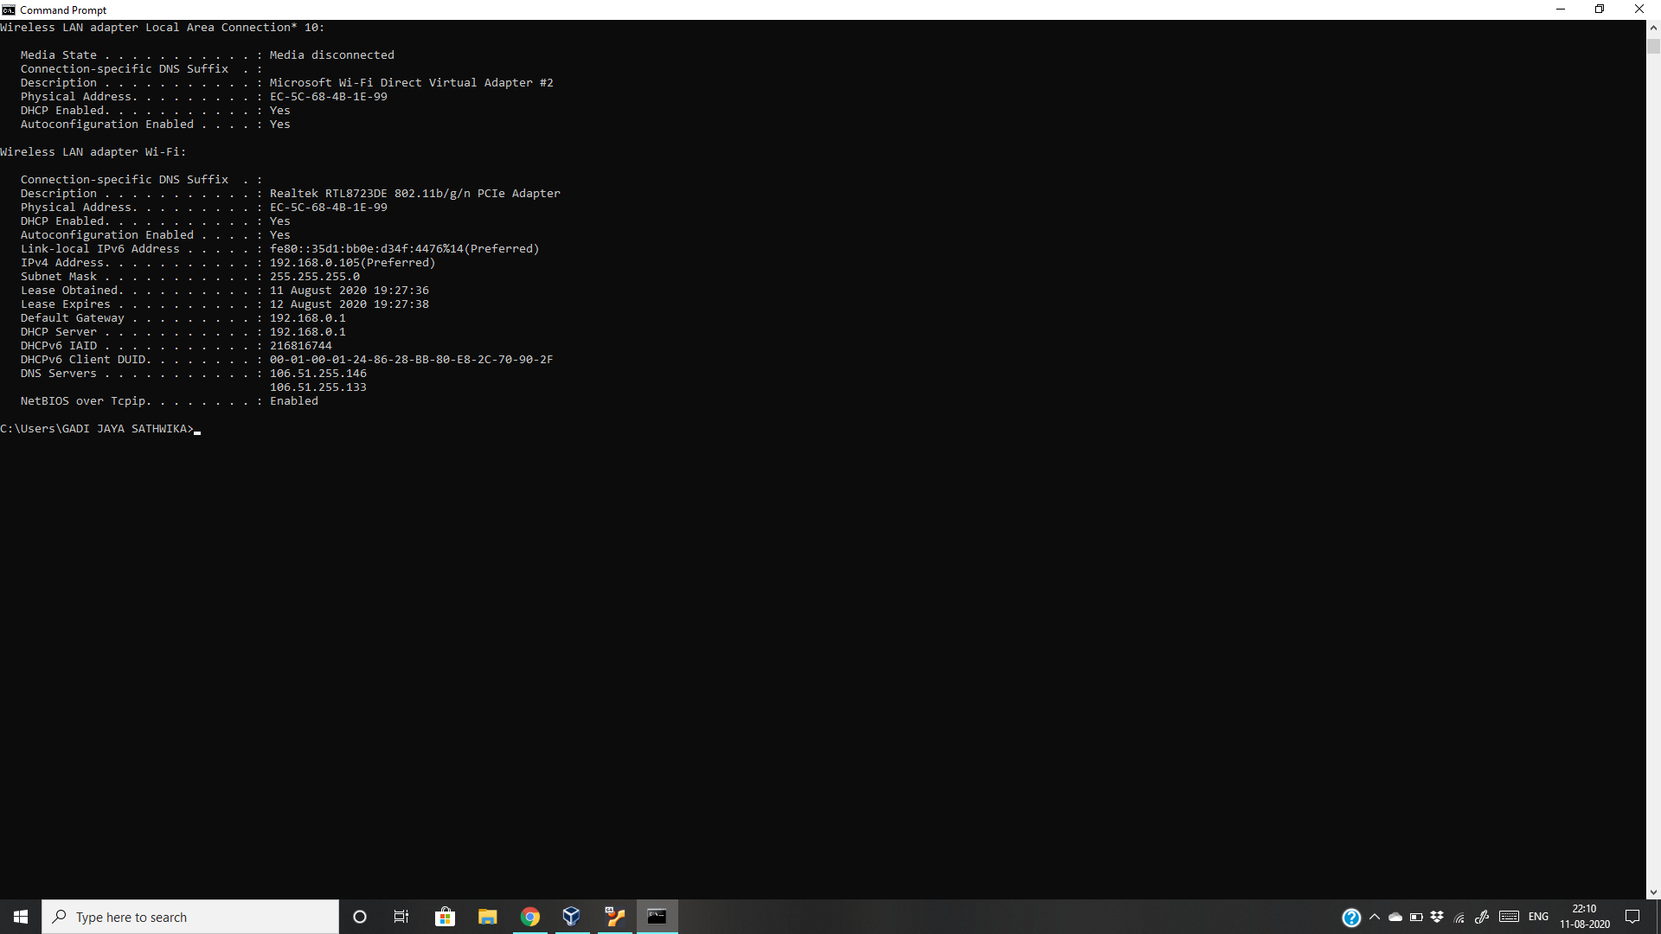

tracert :
tracert google.com
